**CSA1086 - Software Engineering**

MOSCOW Method using Google sheet/Excel

**MOSCOW Method (Must-Have, Should-Have, Could-Have, or Won’t-Have)**

**Step 1: Create a Table**

1. Open Excel and create a new sheet.
2. Create the following headers in row 1:
   * **Requirement**
   * **Category (MOSCOW)**
   * **Justification**
   * **Impact on Users**
   * **Feasibility**

**Step 2: Fill in the Data**

1. List each requirement under the **Requirement** column.
2. For each requirement, analyze it based on:
   * **Impact on Users and Stakeholders**:
     + High impact → Likely a **Must-Have**.
     + Medium impact → Likely a **Should-Have**.
     + Low impact → Likely a **Could-Have**.
   * **Feasibility (Time, Budget, Resources)**:
     + Easy to implement → More likely **Must-Have** or **Should-Have**.
     + Complex or resource-intensive → Likely **Could-Have** or **Won’t-Have**.
3. Based on the analysis, assign a **MOSCOW category** (Must-Have, Should-Have, Could-Have, Won’t-Have) in the **Category** column.
4. Provide reasoning in the **Justification** column for your categorization.

**Step 3: Format the Sheet**

1. Apply bold formatting to the header row.
2. Use conditional formatting to highlight the **Category** column based on the values:
   * **Must-Have** → Green.
   * **Should-Have** → Yellow.
   * **Could-Have** → Blue.
   * **Won’t-Have** → Red.
3. Ensure the **Justification** column is detailed enough to explain your decisions.

To organize and categorize the requirements in Excel using the **MOSCOW Method**, follow these steps:

**Step 4: Final Touches**

1. Add filters to the headers for easy sorting and filtering.
2. Save the file as a **Google Sheet or Excel (.xlsx)** and name it appropriately (e.g., "Library Management System - MOSCOW Analysis.xlsx"). me toppeerrrrrrrrrrrr

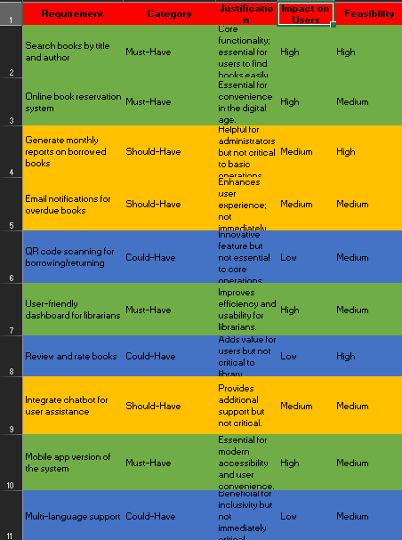s